Language

Spanish

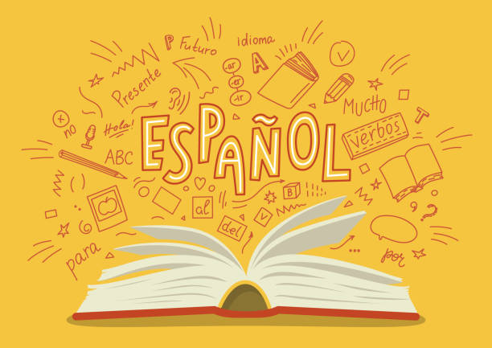

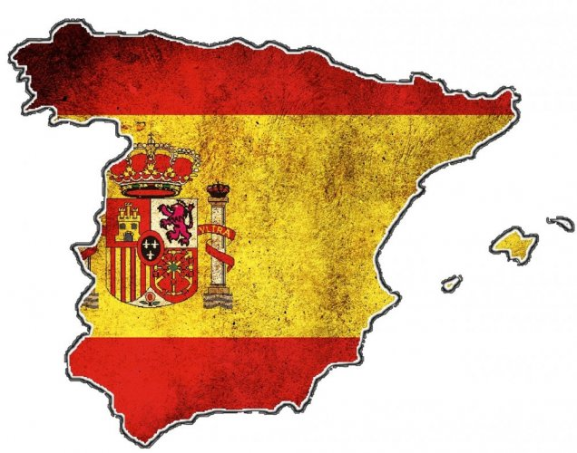

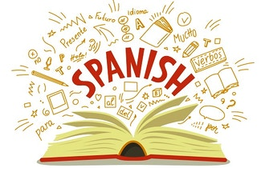

Clare Johnson

1.0 Introduction | 1
2.0 Dispersal & Origin of the Spanish Language | 1-2
3.0 Diffusion of the Spanish Language | 2
3.1 Factor One – Advancements in Transport Telecommunications | 3
3.2 Factor Two – Role Played by Media | 3
4.0 Case Studies | 4
4.1 Case Study One – Adapting the Spanish Language | 4
4.2 Case Study Two – Resisting the Spanish Language | 4
5.0 Implications of the changes in the Nature and Spatial Distribution of the Spanish Language | 5
6.0 Likely future changes in the Nature and Spatial Distribution of the Spanish Language | 5
7.0 Bibliography | 6
Table of Contents

1.0 Introduction
Is the Spanish language a culture?

Culture is an umbrella term that encompasses the social behaviour and norms found in human societies, as well as the knowledge, beliefs, arts, laws, customs, capabilities, and habits of the individuals in these groups. Language is therefore an element of culture due to the fact that it is the communication between people and their beliefs and backgrounds. The Spanish language is therefore a culture.
It originated in Spain, where upon it was dispersed to other place around the world though voyages of discovery and conquest. Due to the expansion 20 other countries have made Spanish their official language, with 460 million native speakers out of the 559 million worldwide. Advancements in transport telecommunications and the role played by media have contributed to the diffusion of the Spanish language in the world. The Spanish language is a culture that has not only been embraced and adapted put also resisted in varies of places around the world. Some of the examples of how the Spanish language are incorporated around the world is use of the Spanglish language and the resistance of the native Mexicans. Since the Spanish language first came about it has had many changes in its nature and spatial distribution and is likely to continue to change and spread in the future.

2.0 Dispersal & Origin of the Spanish Language
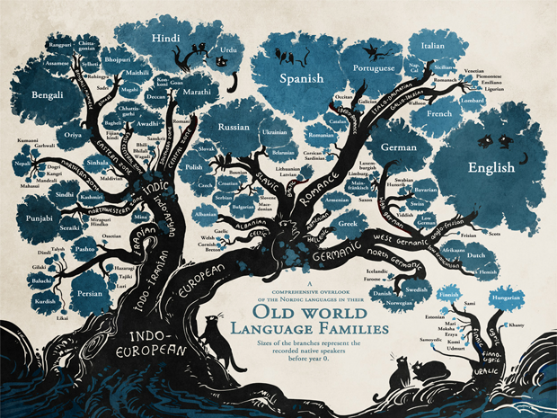
The Spanish language is a language that is largely founded on constant conquest of the Spanish land. First, during the 4th century the Roman Empire’s Latin language (Hispania) mixed with the local languages of its inhabitants. Later that century Visigoths groups conquered some areas, where they introduced their Latin language. These conquered areas were isolated which caused a new language to emerge in the 5th century, Vulgar Latin. The Muslim Moorish conquerors then arrived and contributed words from their Arabic language. Parts of Spain were then conquered by the Moors from Northern Africa and Visigoths from Central Europe, but they were then gradually reclaimed by Christians who spoke Vulgar Latin. By the 13th century Spanish was established in the Kingdom of Castile in the Spanish city of Toledo, which is known as the birthplace of Spanish language.
From the 15th to the early 19th century the Spanish monarchy decided to expand through colonial expansion and conquest. The motivation behind this was to expand trade and spread the Christian faith through indigenous conversions. The 15th and 16th century were a time of voyages of discovery and conquest for the Spanish. One of the first places that the Spanish colonized (and therefore spread their language) was the Philippines. But by the 16th and 17th centuries Spanish was brought across the Atlantic to the Americans by Spanish explores where it spread throughout North, Central and South America as well as the Caribbean rapidly. This was the beginning of the Spanish language spreading to other countries around the world. Some of the places that adopted the Spanish language are Mexico, Colombia, Peru, Chile, Cuba, and Bolivia. Spain was able to colonize 35 different places before they were stop by rivalling countries. These rivalling countries ended up taking 15 of the 35 colonizes form themselves but not before the Spanish language had been taken up by some of the natives. Today there are 20 countries that have officially made Spanish their language but there are many more that speak the language. Due to the fact that there are advancements in transport and technology, the Spanish language has been able to spread rapidly in resent years. Today it has become the third most used language worldwide.
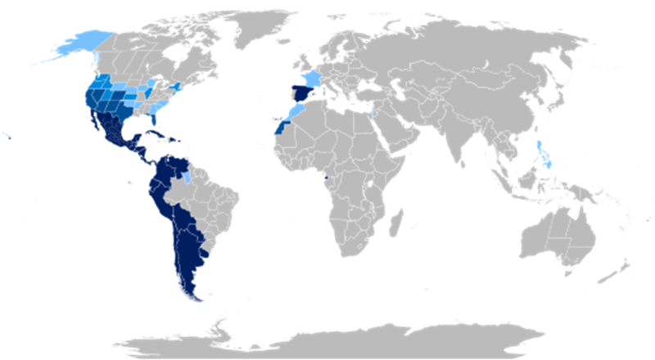
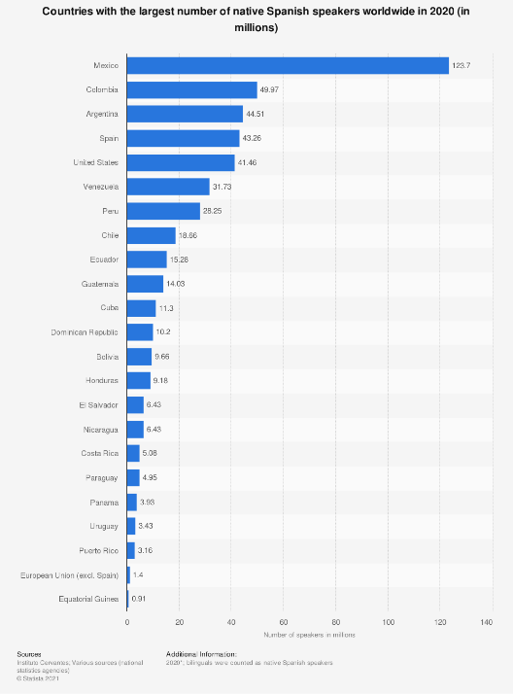
The map on the left shows the countries that have embraces the Spanish language. The dark bule being the countries that have made Spanish their official language. The other two bule shades being the amount of people that speak the language, the lighter bule with less people speaking Spanish. The table on the right show the countries that have the largest amount of native speaker of Spanish.
Spain: origin of Spanish language
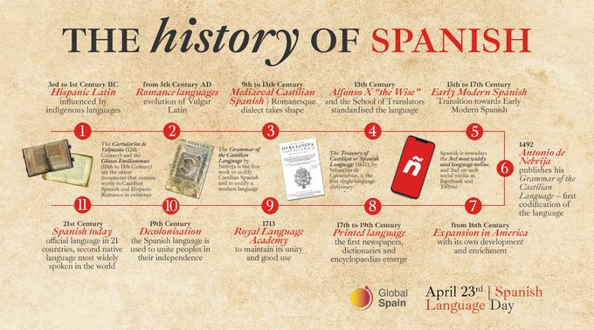

3.0 diffusion of the spanish language
Diffusion is the spread of technologies, products, and ideas from their points of origin to other areas. The Spanish language was diffused around the world after it was first established in Spain in the 13th century, it went over seas to places such as Mexico and Bolivia. The Spanish colonized and conquered places around the world which meant that their language spread with them. Today it is a well-known language that is the third most spoken as it has diffused so much. Some of the reasons why it was able to spread is due to the fact of advancements in transport, other emerging technologies, the role played by trinational institutions and/or corporations and the media.
3.1 factor one – advancements in transport telecommunication


The Spanish language first started its diffusion from Spain in the 13th century, when the transport and telecommunications were first being developed, therefore the diffusion was slow. The Spanish traveled by cart and foot on land and boat by sea but with the advancements they were able to travel at a faster pace across larger distances. This enabled the language to diffuse quicker and further. Steamboat with the ports and harbors, roads with the vehicles, railroads with the trains and airports with the airplanes. They all helped to make the diffusion of the Spanish language easier and faster. The explores in the 15th and 16th century first started the spreading the Spanish language through the use of boats due to the fact that they were developed sooner then vehicles and airplanes. The boats help the Spanish language to spread to countries on distant lands over the span of weeks. Next the vehicles were developed which meant that people were able to travel across land quicker over the span of days. And then the airplanes which meant that people could travel to places in the matter of hours rather than days or weeks. The development of telephones enabled people to communicate across vast distances which helped to spread the Spanish language. The development of phones and the internet meant that people were able to interact easier across large distances. It also meant that people could learn the language with more ease. The two images below show the trains evolving and becoming able to transport people across large distances at faster pace.

3.2 factor two – Role Played by Media


Media is commonly used by most people; it is a way that people communicate and interacted across both vast and close distances. It is also used to entertain and inform people of the happenings around the world. The Spanish language is able to spread via media with people those that use the Spanish language. The Spanish language in media can be used to advertise which can make people try and understand parts of the language. Platforms created by social media that use Spanish are how customers are influenced to buy product or services. The publication of Spanish through the use of media was at 27.5% in 2016. In 1975 the transition of dictatorship to democracy in Spain enabled both public and private media to become a cornerstone of public life. This meant that the Spanish language was used more on media and was therefore likely to spread to other people around the world. With people always on interacting with the media they would pick up bits and pieces of the Spanish language. The social media and the news broad casts things from all over the place which people can pick up.
4.0 CASE STUDIES
When an element of culture is diffused to other places it may be either embraced, adapted, or resisted. Embracing is the acceptance (of a belief, theory, or change) willingly and enthusiastically. Adapting is making (something) suitable for a new use or purpose; modify. Resisting is withstanding the action or effect of a thing. The Spanish language was dispersed around the world, and therefore it was embraced, adapted, and resisted in many areas. Spanglish is an example of an adaption and the native Mexican fight the Spanish and their language is an example of resistance.
4.1 Case Study One – adapting the spanish language
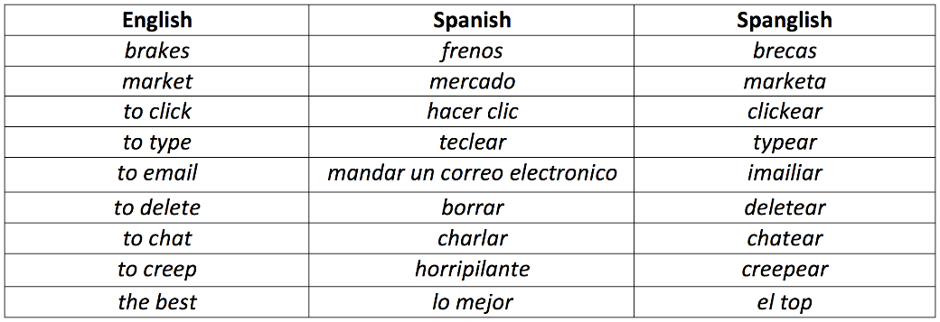
Adaption is the modification of a technology, product, or idea from elsewhere to suit local conditions. Alternatively, the changes are the response to an external force. Spanglish is an adaption of the Spanish language. Those that speak Spanish have altered the way that they say some things. It is a combination of both English and Spanish that is spoken by both English and Spanish people. It is a crossed over from the street to Hispanic talk shows and advertising campaigns. Primary it is the language of the poor Hispanics as they lack the vocabulary and education in Spanish to adapt to the changing culture around them. However, the educated Hispanics that are embarrassed by their background feel empowered by using English words, so they also use Spanglish. Politically, Spanglish is the submission of Spanish, as it indicates marginalization, not enfranchisement but many people use Spanglish any way. Spanglish speakers are multilingual. The acquiring of Spanglish is something that comes after learning one’s native language. The majority of Spanglish speakers are raised in homes in the United States, where they speak Spanish at home and English at school or among other members of society. As Spanglish is the linguistic phenomenon of ‘code-switching’ which refers to when a speaker switches between languages in a conversation, it is an adaption of the Spanish language. Those that speak Spanglish begin to speak English with the rules of Spanish, or vice-versa. Due to the fact that the Spanglish is an adaption it varies with its different dialects between families and regions.

4.2 Case Study Two – Resisting the spanish language
Resist is withstanding the action or effect of a thing. When the Spanish first started their expansion through Mexico in the early 15th century there was a resistance by the natives and therefore resistance of the Spanish language. The areas in the southern of Mexico had effective indigenous resistance by the Yucatán, inhabited by Maya societies. By 1526 the region was conquest. However, there was still Maya resistance of the Spanish and their language. It took another 20 years the expand to the north, with more resistance there. Some indigenous peoples remained independent for another century and a half, because of this there was a need for defense against nomadic indigenous raiders. Throughout the mid to later 15th century there was a prolonged fight amount the Spanish and natives of Mexico. There were Spanish settlers who established missions in Mexico to try and teach the natives the Spanish language and the Spanish beliefs.

5.0 Changes in the Nature and Spatial Distribution of the spanish language
The Spanish language originated from a range of different languages over a few centuries but has not changed overly much in the last few centuries. However, it did begin borrowing words and grammar from several other Roman languages such as Iberian, Celtic, Celtiberian and Basque early on when it was first established. The French, Italian and Portuguese did heavily influence the Spanish language. With the Spanish language spreading to other countries around the world such as South America it has transformed into many unique and local dialects. As the Spanish language evolved from the Latin language there are similarities but one of the main changes is that the Spanish language is softer. For instance, ‘stone’ in Latin is ‘petra’ with a hard ‘t’ but ‘piedra’ in the Spanish language is with a soft ‘d’. The advantage of the Spanish language being distributed around the world is that a large range of people speak the same language in many areas, therefore they can communicate easily. The disadvantages of the Spanish language be distributed around the world is that other languages and cultures have been changed or forgot due to the Spanish language taking over. An example is when the Spanish tried to take over the Philippines and teach them Spanish, they suppressed the Pilipino language and changed it in areas, this is a national scale. The Spanglish language is a change locally of the Spanish language. Those that learn the Spanish language around the world are examples of people that are changing the spatial distribution of the language.
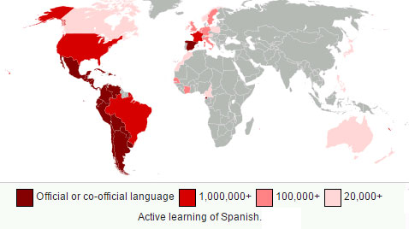
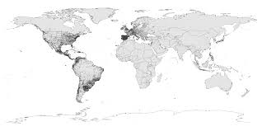

6.0 Likely future changes in the nature and spatial distribution of the spanish language
In the future the Spanish language is likely to change slightly as there are other languages out there that can influence it, but there will be more places that will adopt and adapt the language due to the fact that it is a dominant world language. More and more people around the world will embrace the language as they are doing today also because it is a world language. It is becoming more of a necessary language in the world due to the amount of people that speak it and the us it has. There are some workplaces that currently pay people more if they can speak the Spanish language therefore it is likely to spread around the world more. New languages will also evolve from the Spanish language like the Spanglish language. On a local level in Spain the language is not likely to change. International the language will evolve and have some slight differences. The United States estimates that there will be 754 million people that speak Spanish in 2050.

7.0 Bibliography
Amstutz, A., 2021. The History of the Spanish Language | Lingvist. [online] Lingvist. Available at: <https://lingvist.com/blog/history-of-spanish/> [Accessed 14 September 2021].
Bierly, R., 2021. Spanglish: The Validity of Spanglish as a Language. [online] Panoramas. Available at: <https://www.panoramas.pitt.edu/opinion-and-interviews/spanglish-validity-spanglish-language> [Accessed 20 September 2021].
Britannica, E. (2021). Mexico - Expansion of Spanish rule. Retrieved 15 September 2021, from https://www.britannica.com/place/Mexico/Expansion-of-Spanish-rule
Florian, A., 2021. In China, millennials embrace Spanish, Latino culture and shake it up on TikTok. [online] NBC News. Available at: <https://www.nbcnews.com/news/latino/china-young-people-are-learning-spanish-embracing-latino-culture-rcna389> [Accessed 10 September 2021].
Gonzalez Echevarria, R. (2021). Opinion | Is 'Spanglish' a Language? (Published 1997). Retrieved 20 September 2021, from https://www.nytimes.com/1997/03/28/opinion/is-spanglish-a-language.html
Press Books, P., 2021. 5.3 CLASSIFICATION AND DISTRIBUTION OF LANGUAGES – Introduction to Human Geography. [online] Opentext.wsu.edu. Available at: <https://opentext.wsu.edu/introtohumangeography/chapter/5-3-classification-and-distribution-of-languages/> [Accessed 8 September 2021].
Salaverria, R. and Baceiredo, B., 2021. Spain. [online] Media Landscapes. Available at: <https://medialandscapes.org/country/spain> [Accessed 14 September 2021].
Stone, R., 2021. The Spanish Language I Rosetta Stone. [online] Rosetta Stone. Available at: <https://www.rosettastone.com/languages/spanish-language> [Accessed 10 September 2021].
Translations, L., 2021. Spanish is a Truly Global Language. [online] Legal Translations. Available at: <https://legal-translations.com.au/spanish-truly-global-language/> [Accessed 8 September 2021].
Weedon, A., 2019. 'Most don't realise they're speaking Spanish': The revival of the Philippines' disappearing language. [online] Abc.net.au. Available at: <https://www.abc.net.au/news/2019-08-10/inside-the-push-to-bring-back-spanish-into-the-philippines/11356590> [Accessed 10 September 2021].
Worlddata.info, 2021. Spanish - Worldwide distribution. [online] Worlddata.info. Available at: <https://www.worlddata.info/languages/spanish.php> [Accessed 14 September 2021].
With Style, S. (2021). The Evolution of the Spanish Language | Spanish with Style. Retrieved 21 September 2021, from https://spanishwithstyle.com/the-evolution-of-the-spanish-language/

